BYGGSØK building
Version– Part – Selvbygger

Versions

Rev nr. | Date | Description | Author
0.9 | 16.10.2012 | First document for approval | Anna Schultz
 | 17.10.2012 | Comments from Dibk | Hilde G. Larsen
1.0 | 01.11.2012 | Made changes according to comments from Dibk | Anna Schultz
1.1 | 12.11.2012 | 1.1.5 is added | Anna Schultz
1.2 | 14.11.2012 | 1.3 added for Reports | Anna Schultz
1.3 | 20.11.2012 | Changed spec according to XML schema structure for Parts/Roles and comments from developer | Anna Schultz
1.4 | 28.02.2013 | Changed due to fagområder. Selvbygger removed as separate fagområde. | Hilde G. Larsen
1.5 | 12.03.2013 | Text added in red under 1.1.1. | Hilde G. Larsen
1.6 | 13.03.2013 | More text added in red | Hilde G. Larsen

Content

1 Owner as a responsible part (Selvbygger) 4
1.1 GUI pages 4
1.1.1 Menu Parter – Tiltakshaver. 4
1.1.2 Menu Parter – Selvbygger 5
1.1.3 Menu Gjennomføringsplan 6
1.1.4 Menu Gjennomføringsplan – Egenerklæring 9
1.2 Locking and signing 10
1.2.1 Selvbygger – the only responsible part. 10
1.2.2 Selvbygger as an ansvarlig søker. 12
1.2.3 Selvbygger is not an ansvarlig søker. 12
1.3 Reports 13
1.3.1 Gjennomføringsplan 13
1.3.2 Egenerklæring- Selvbygger 13
1.3.3 Ansvarsrett – Selvbygger 13

Owner as a responsible part (Selvbygger)

Owner of the property (usually also a tiltakshaver) can be a responsible part in the application and can apply for all or some areas of responsibility in line with companies (foretak).
It requires some new functionality for the system.

GUI pages

Menu Parter – Tiltakshaver.

Figure 1, nr1.

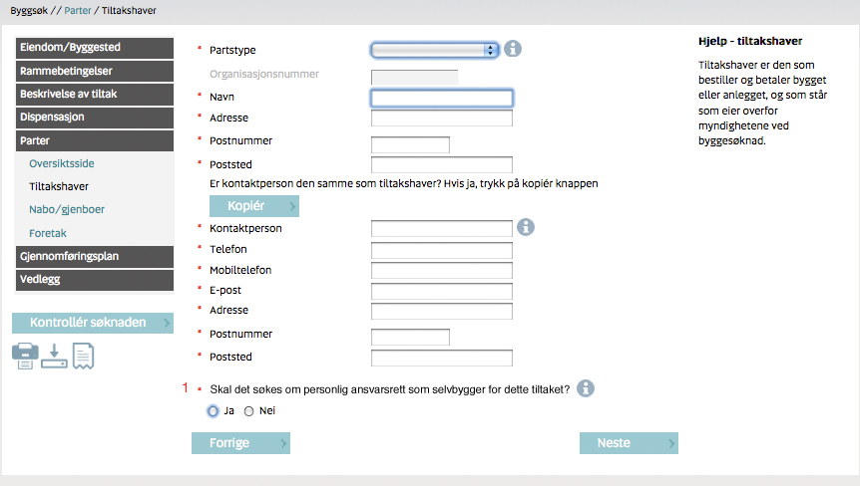
Figure 1

If Ja, then new submenu – Selvbygger appears under menu Parter. If Nei, then submenu – Selvbygger is not shown.
See figure 2.

Nr 1 is active in application types Nabovarsel, Dispensasjon, Rammetillatelse, Ett-trinnsøknad and IG.
If set in Nabovarsel, then can be changed in the next following application.
If set in Rammetillatelse then can’t be changed in the all next following applications within a building case except for using “Endring av tillatelse/Endring av ansvarsretter. The same for Ett-trinnsøknad.

If Nr1 changed from Ja to Nei in the current application, then all information entered for Selvbygger in this application should be removed. That does not include Fagområde and Area of responsibility. Before removing the data, a warning-box has to appear and the choice from Ja to Nei must be confirmed.
Text in the warning-box: “Alle data lagt inn i menyen “Selvbygger” vil bli fjernet. Ønsker du å fortsette?” And the choices “Ja” or “Angre” will appear. If “Ja”, the procedure as described can continue. If “Angre”, the previous picture will appear and Nr1 remains as “Ja”.
Area of responsibility that has been register on selvbygger should be possible to pass over to an ”Ansvarlig foretak”.

Menu Parter – Selvbygger

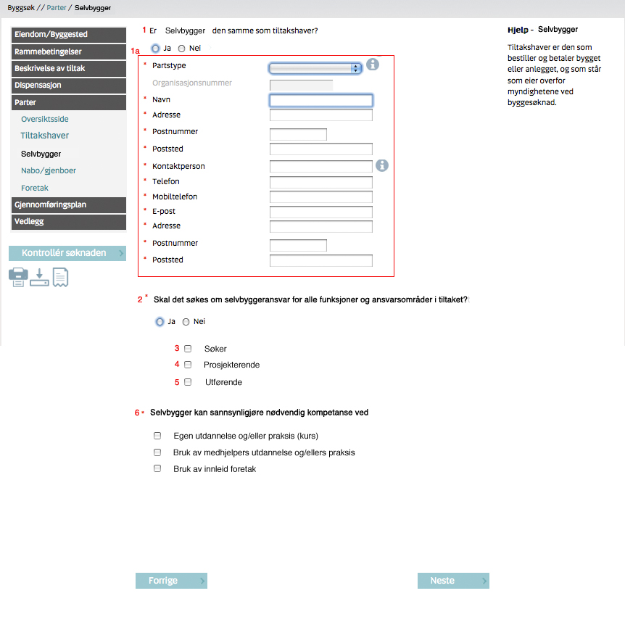
Figure 2

Figure 2 Nr1 – if Ja, then the block of information -1a - is dimmed (filled with data from menu Tiltakshaver – read only). Then Tiltakshaver is Selvbygger.
If tiltakshaver is not a private person, nr 1 shall be fixed on “nei”.

If No, then the block of info – 1a - is active and a new part type will be added to application.
“Partstype shall be pre-set to “Privatperson”. There shall not be possible to choose any other type.

Figure 2 nr 2:
If application type - Rammetillatelse or Ett-trinns søknad then:

If nr 1 Ja, then nr 3, 4 and 5 is dimmed (inactive) and menu Gjennomføringsplan is not shown.
If nr 2 Nei, then nr 3, 4 and 5 are active.

If 3 is checked then see figure 3.
If 4 is checked then see figure 4.
If 5 is checked then see figure 5.

If nr 1 in figure 2 is switched from “Nei” to “Ja”, then all the data that are registered in the menu “Gjennomføringsplan” shall be removed after confirming a warning box.

When application type is IG or part IG then nr 1, 1a, 2 and 6 is dimmed and data are pre-chosen as in previous application.

Menu Gjennomføringsplan

1.1.3.1 Sub menu Fagområder
The same functionality as for any application

Sub menu Ansvarsfordeling – Søker

Figure 3

Nr 1 set to Selvbygger – navn are dimmed if nr 3 in figure 2 is chosen.
Nr 2 is not shown.

Sub menu Ansvarsfordeling – Prosjektering

Figure 4

Application types where it is mandatory to have at least one entry for Prosjektering should still have it even when Selvbygger is the only responsible part for Prosjektering.

If no 4 in figure 2 is checked:
Nr 1 - “Ansvarsområde gjelder selvbygger” is available
If no 1 in figure 4 is checked, then:
Nr 2 is set to “1 “
Nr 4: Selvbygger (Tiltakshaver) can be chosen from the list of responsible parts.
Nr 5 is not shown
Nr 3 (area of responsibility) is not linked to Samsvarserklæring.

Sub menu Ansvarsfordeling – Utførelse

Figure 5

Application types where it is mandatory to have at least one entry for Utførelse should still have it even when Selvbygger is the only responsible part for Utførelse.

If no 5 in figure 2 is chosen:
Nr 1 - “Ansvarsområde gjelder selvbygger” is available
If no 1 in figure 5 is checked:
Nr 2 is set to “1 “
Nr 4: Selvbygger (Tiltakshaver) can be chosen from the list of responsible parts.
Nr 5 is not shown
Nr 3 (area of responsibility) is not linked to Samsvarserklæring.

Menu Gjennomføringsplan – Egenerklæring

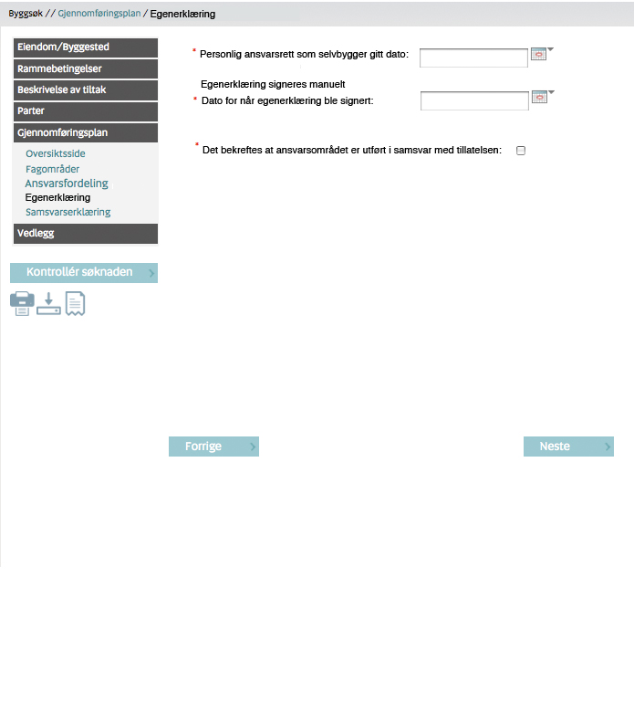
Figure 6

This submenu appears only when application types: midlertidig brukstillatelse and/or ferdigattest.
This submenu appears only if Selvbygger is a Part and contains data from earlier applications in the building case.

Egenerklæring is not linked to any area of responsibility as in Samsvarserklæring.

Locking and signing

Selvbygger – the only responsible part.

Figure 2.
If nr 2 Ja, then
- There are no any other responsible persons or companies in the application besides Selvbygger (tiltakshaver).
- Application must be locked (figure 7) when all mandatory fields are entered and can be sent electronically to the municipality without signatures (figure 8). Application can be unlocked from the same page before it was sent.

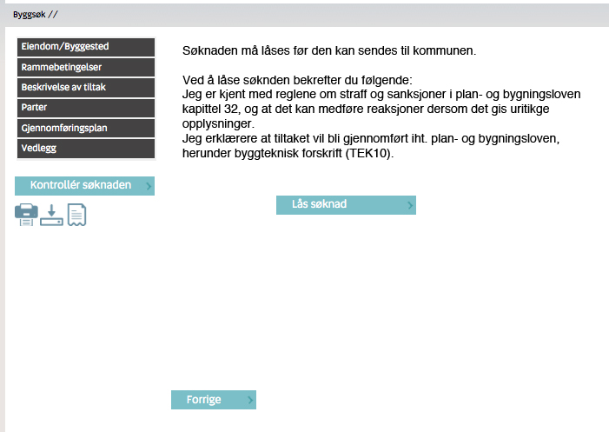
Figure 7

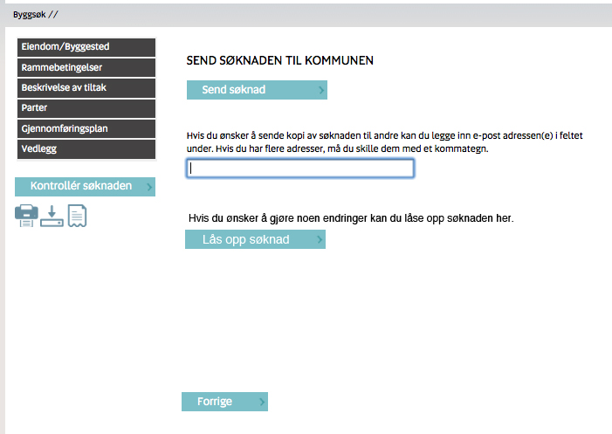
Figure 8

Selvbygger as an ansvarlig søker.

Selvbygger is not able to sign electronically on behalf of other responsible parts.

Figure 2
If nr 2 is Nei and nr 3 is checked, then:

- There are other companies with areas of responsibility for prosjektering or/and utførelse in the application, which have to be signed.
- Areas of responsibility, which belongs to Selvbygger cannot be signed electronically. There should be an attachment “Søknad om ansvarsrett” uploaded to the application when Selvbygger applies for responsibility for “prosjektering” or “utførelse”.
- Application must be locked (figure 7) when all mandatory fields are entered.
- Signing process lasts until every responsible company signs its area of responsibility.
- Selvbygger (in this case as ansvarlig søker) can follow signing process by checking “Kontrollér Søknad” – button.
- When everybody signed, application can be sent to the municipality (figure 8).
- Application can be unlocked and all signatures removed from the same page by Selvbygger.

Selvbygger is not an ansvarlig søker.

Figure 2
If nr 2 is Nei and nr 3 is not checked, then:

- Ansvarlig søker is a company (foretak) as usually.
- All areas of responsibility, which belongs to Selvbygger cannot be signed electronically. There should be an attachment “Søknad om ansvarsrett” uploaded.
- Signing process for other responsible parts flows as usual.

Reports

Gjennomføringsplan

If Figure 2 nr 2 – Yes, then there is no report “Gjennomføringsplan” in the building case.

If Figure 2 nr 2 – No, then report “Gjennomføringsplan” should be sent as usual. Area of responsibility for Selvbygger Prosjektering and/or Utførelse (figure 4 and figure 5) has to present on the report in the same way as for any other responsible part.
Column “Organisasjonsnummer” in the report should have value – “Selvbygger” for area of responsibility for Selvbygger.
See “Mapping XML – SN forms NYPBL 20121114” – tab “Gjennomføringsplan”.

Egenerklæring- Selvbygger

It can be only one Egenerklæring for Selvbygger in the building case.
Report is created in the midlertidig brukstillatelse or ferdigattest application types.

Egenerklæring will never be sent automatically (electronically) to the municipalities. It will be just stored in the building case.

See “Mapping XML – SN forms NYPBL 20121114” – tab “Egenerklæring - Selvbygger” for report specification.

Ansvarsrett – Selvbygger

“Søknad om ansvarsrett for selvbygger” do always have to be signed manually and loaded up as an attachment. The printout shall never be sent automatically from the system.

See “Mapping XML – SN forms NYPBL 20121114” – tab “Ansvarsrett - Selvbygger” for report specification.

